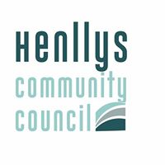

HENLLYS COMMUNITY COUNCIL
CYNGOR CYMUNED HENLLYS
Clerk/Treasurer: Adrian Isaacs, Henllys Village Hall, Henllys, Cwmbran, NP44 6JZ
Clerc y Cyngor/Trysorydd: Adrian Isaacs, Neuadd Pentref Henllys, Ffordd Pentref Henllys, Henllys,
Cwmbran, NP44 6JZ
Tel: 07703194263

To the Chair and Councillors, Henllys Community Council
You are summoned to attend a meeting of Henllys Community Council to be held at the Village Hall on
Monday 12th May 2025 immediately after the AGM which starts at 6pm

AGENDA

- Questions from the public.

- Attendance & Apologies for absence.

- Declaration of interests.

- Approval of minutes - 14th April 2025 *

- Matters arising and actions from those minutes (not covered by the agenda).

- Approval of Payments of £500 or more ( excluding VAT ) :

- Income & Expenditure , year to date *

- Notes of Business Planning & Finance Working Group – 23rd April 2025 *

Council is requested to consider the information provided by TCBC in relation to the request for bus shelters .

9. Draft Business Plan 25-26 *

10 .Grant Applications

11. Chair’s report

12. .AOB

Date of next meeting – 9th June 2025

( * Denotes document attached )

