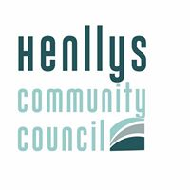

HENLLYS COMMUNITY COUNCIL

Mr A Isaacs , Clerk/Treasurer, Henllys Village Hall, Henllys Village Road, Henllys, Cwmbran, NP44 6JZ
Mr A Isaacs , Clerc y Cyngor/Trysorydd, Neuadd Pentref Henllys, Heol Pentref, Henllys, Cwmbran, NP44 6JZ

Tel: 07703194263

ANNUAL GENERAL MEETING

MONDAY 9th MAY 2022 at 6.00 pm
MINUTES

- In attendance

- Cllr’s Waters , Smith-Higgins , Lewis , Everett , Thomas & Burnett

- Clerk

- Election of Chair

- Cllr Smith-Higgins was elected .

- Election of Vice Chair

- Cllr Waters was elected .

- Declarations of Interest

- None

- Minutes of 2021 AGM

- Agreed

- Matters Arising

- Nothing additional to matters already on the agenda

- Retiring Chair’s Report

- Confirmation of Cheque Signatories

Agreed - Cllr Everett, Cllr Burnett, Cllr Waters and Cllr Lewis.

- Election of members with special responsibility and of representation

Henllys Village Hall | Cllr Burnett
Emergency Officer | Cllr Burnett
Henllys CC Business Planning & Finance Working Group | All Members
Henllys CC HR Working Group | Cllr Waters, Cllr Smith-Higgins,  Cllr Everett

