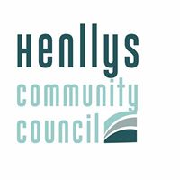

QUESTIONS TO HENLLYS COMMUNITY COUNCIL

DUE TO COVID 19 RESIDENTS ARE UNABLE TO ATTEND MEETINGS OF THE COMMUNITY COUNCIL AND ASK QUESTIONS .

THE COMMUNITY COUNCIL IS MEETING AND IF YOU HAVE ANY QUESTIONS PLEASE E-MAIL THE CLERK at :

clerk@henllys-cc.gov.wales

Mr A Isaacs , Clerk/Treasurer, Henllys Village Hall, Henllys Village Road, Henllys, Cwmbran, NP44 6JZ
Mr A Isaacs , Clerc y Cyngor/Trysorydd, Neuadd Pentref Henllys, Heol Pentref, Henllys, Cwmbran, NP44 6JZ

Tel: 07703194263

