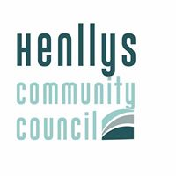

DORALLT PARK

When you use the Park please follow the rules below

- MAINTAIN SOCIAL DISTANCING

- DO NOT EAT OR DRINK IN THE PARK

- PUT ANY LITTER IN THE BIN

- BE COURTEOUS TO OTHERS WAITING TO USE THE EQUIPMENT

- THERE IS NO HANDWASHING FACILITY IN THE PARK

THE COMMUNITY COUNCIL WILL NOT TOLERATE ANY BAD BEHAVIOUR OR ABUSE TOWARDS STAFF CARRYING OUT THEIR DUTIES

ADRIAN ISAACS
CLERK TO HENLLYS COMMUNITY COUNCIL
Tel : 07703194263
Email: clerk@henllys-cc.gov.wales

