HENLLYS COMMUNITY COUNCIL
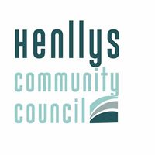

GRANTS APPLICATION FORM

Thank you for your enquiry about a grant from Henllys Community Council.
Please complete this form & email to :

clerk@henllys-cc.gov.wales

or post to :

Henllys Community Council , Village Hall, Henllys
Cwmbran NP44 6JZ

If you would like assistance in completing the form contact the Clerk on
07703194263

1. Name of your organisation

2. Where does your organisation meet

3. Name, address, telephone number and email address of the person in your organisation who will be used as the Council’s contact .

4. Aims and objectives of your organisation.
Within this section please comment on the environmental impact of your activities . ( This will help the Community Council meets its responsibilities under the Environment Wales Act 2016. )

5. State the reason your organisation is applying for a grant. Please be as specific as you can and state the amount you are requesting, if this is known

6 State the connection your organisation has with the Henllys Community.

7. DECLARATION

I certify that the information provided in this application is, to the best of my knowledge and belief, correct and complete.

Please print your name _______________________________

Your position
in your organisation ____________________________

Date ______________________________

Your data will be collected by the Council and processed to perform a task in the public interest or in exercise of its official authority. Information will not be shared with third parties

